Phase B: Preliminary Design and Technology Completion

Brandon Hickey

9/23/2023

Following: <https://www.eng.auburn.edu/~dbeale/ESMDCourse/Chapter2.htm>

# Purpose

To define the project in enough detail at all levels (system, subsystem and components) to establish a Preliminary Design that has no unresolved design or technology issues. Per [2], a Preliminary Design “meets all the system requirements with acceptable risk and within cost and schedule constraints and establishes the basis for proceeding with detailed design. It will show that the correct design option has been selected, interfaces have been identified, and verification methods have been established.”

# Trade-Studies

## Option #3 Trainer style, High-Wing, Single Engine

This is a basic model used for many beginners in remote-controlled fixed-wing aircraft. The high-wing design and potential dihedral provides more stability in flight and would have the motor mounted to the nose, providing thrust in line with the center of mass and low wiring complexity to connect motor to control. It does have the issue of needing to angle the motor (Thrust angle) to counter aircraft tendencies. With a single engine we will need to be more cautious of our weight and payload constraint, however the ease of designing and manufacturing with less required strength on the wings than a multi-engine frame would offset this.

## Trade Study Result

|  |  |  |  |  |  |
| --- | --- | --- | --- | --- | --- |
| Criteria | Weight | Twin Boom 1E | Twin Boom 2E | Trainer 1E | Trainer 2E |
| Score | Score | Score | Score |
| Expected Ease of Designing | 15 | 6 | 3 | 12 | 9 |
| Expected Ease of Manufacturing | 10 | 6 | 4 | 8 | 6 |
| Expected Ease of assembling | 15 | 6 | 3 | 9 | 6 |
| Durability/Rigidity | 10 | 8 | 6 | 8 | 6 |
| Maneuverability | 10 | 8 | 10 | 6 | 6 |
| Aesthetic/Personal Taste | 5 | 3 | 4 | 2 | 4 |
| Stability | 15 | 9 | 9 | 12 | 12 |
| Weight w/o Payload | 10 | 8 | 6 | 8 | 6 |
| Payload Capacity | 10 | 4 | 6 | 4 | 6 |
| Total | 100 | 58 | 51 | 69 | 61 |

Based on an overview of the frame type, we can conclude that for at least a first full attempt, the trainer is the most viable option for success. While it does not contain as much potential thrust as the multi-engine frames, its ease of design, manufacturing, and assembly, along with natural stability, makes it a clear choice. Moving forward, we will perform our reviews and development with the Single-Engine High-Wing Trainer.

# Plane Design Specifications

This will be based on a design generator from <https://rcplanes.online/design.htm> that will be used to feed in some design parameters to develop a trade study for several given wingspans and wing chords.

## Reynolds Number

I will be working with a Reynolds number, Re, to aid in understanding the relationship with the airflow as well as for selecting an airfoil type that will be used within the plane design to determine my flight performance.

Reynolds number is given by:

Re = (air density / air viscosity) * air speed * wing chord.   
  
Of these we have some standard values for Air Viscosity and Air Density, followed by our inputs of air speed and wing chord. We have a rough goal in mind of our target airspeed given in the SE Function #1 of 9 – 13.5 m/s cruising speed. We will then combine this Re with the trade study of wingspans and wing chords to determine performance between options.

## Trade Study

Using the generator, we have 5 inputs per design. While these may all result in different sizes and weights, we are going to assume that our final design for each version will be at the max weight of 1,000 grams.

## Lift Study

We have 4 main sets of data to look at based on two variables: Cruising Speed, and Aspect Ratio. For all sets, we used a wingspan range from 250 mm to 1500 mm. From there we have the high and low end of our desired cruising speed as the two points (9m/s and 13.5 m/s). Lastly, we have the aspect ratio of the aircraft.

With each set we calculate the attached Reynolds Number that is based on the outputs of the generator and our input variables. To simplify things in terms of available Airfoil models, we are using a S7055 flat-bottomed airfoil model with three potential Reynolds Number Versions: 50,000, 100,000, and 200,00. The range of each is based on which is closer to the other. Anything with a Re lower than 75,000 will use the 50,000 version. Anything between 75,000 and 150,000 will use the 100,000 version. And all of the above will use the 200,000 version.

The results of each will then look at the lift generated at 3 angles of attack (AoA): 0, 5, and 10 degrees. We will then identify on the plot whether a given generated set not only can handle the max 1 kg aircraft weight, but also handles the additional 300g payload. From this test, we will determine the most likely to succeed candidates, then perform another round of testing with more defined Wingspan and Cruising speed values after removing all unlikely candidates.



From the results, we can make several assumptions.

1. Our cruising speed must be higher than 9 m/s. At no testing set did we maintain a greater lift than the weight of our vehicle for any available wingspan, speed, and aspect ratio. However, we did succeed in both aspect ratios in providing enough lift at the high end of our cruising speed.
2. We must reduce our maximum possible wingspan: From the generator results, we notice that at our highest aspect ratio of 6:1, our average chord length at a wingspan of 1500 mm was 250mm, greater than our desired maximum build size. We also noted that 1250 mm was too large. Based on this, we can decide that for an aspect Ratio of 6, we can not have a larger wingspan than 1200mm and for an aspect ratio of 5 we can not have a larger wingspan than 1000mm. This, however, does not provide any successful datasets. So, we will perform our test again, with the following constraints and changes.
   1. Wingspan at AR 6: 1200 mm
   2. Wingspan at AR 5: 1000 mm
   3. Max cruising Speed: 15 m/s

This provides the following new results:



We now have an additional set of possible configurations that satisfy both of our constraints. If we remove the options that have too large of build size, we are left with the following options:

1. Aspect Ratio 5, Wingspan 1000 mm, Cruising Speed 17 m/s
2. Aspect Ratio 6, Wingspan 1200 mm, Cruising Speed 15 m/s
3. Aspect Ratio 6, Wingspan 1200 mm, Cruising Speed 17 m/s

From here, we must decide what we value more. Both vehicles will have the same average chord length, the 1200 mm wingspan vehicles will have not only the additional 200 mm of material to manufacture for the wings, but an additional 150 mm in fuselage length. While this can provide more room, it will create more weight for the overall vehicle. This may cause us to run against our max weight constraint more often than with the 1000 mm wingspan. Therefore, we will move forward with option #1: Aspect Ratio 5, Wingspan 1000 mm, Cruising Speed 17 m/s.

## Drag Study

Next, let’s take a look at the drag this will produce. We have yet to decide on a motor/propellor set, but we should be able to develop a reasonable expectation for desired thrust based on the weight of our vehicle and drag.

I believe my main focus will be focusing on the drag during cruising conditions, so I will look at the same AoA.

**This study is currently missing drag due to everything else but the wings. Needs work\*\*\***

Looking at the results, The Drag at each AoA is as follows: 0.276 @ 0 deg, 0.334 @ 5 deg, and 0.594 @ 10 deg.

Based on this drag, we can estimate using a free-body diagram to determine the required thrust needed to maintain a speed of 17 m/s.

At 0 degrees angle of attack, we are looking at just the drag of the aircraft versus the thrust of the engine. Meaning us to stay at the same velocity we must produce at least 0.276 newtons of thrust, or **28 grams of thrust? This seems off, but I must also consider that I am not including drag from any other component in this calculation.**

**I believe my next step will be to attempt either a simple python, matlab, or excel script to calculate the thrust required to accelerate from standstill to take-off.**

**Assumptions of the simulation:**

1. Maximum weight and payload
2. Assume plane stays at an AoA of zero degrees
3. Assume the plane leaves the ground and remove friction from the wheels at this point
4. Runway length of 50/100/200/500 feet
5. AoA while on ground of 0/5/10 degrees

## Take-off Study

Looking at the results of our model, we note that leave the ground at roughly 1.91 seconds, clearing 1 meter from the ground at 2.76 seconds. Look at our x-position, we can determine how long of a runway we needed to take-off which is equal to roughly 17.6 meters or 57.75 feet. Our speed at take-off is equal to 15.64 meters per second, close to our excel calculations regarding minimum speed to produce lift equal to our weight and max payload. The local RC field has a runway of 200 feet, meaning it will be satisfactory location and distance for this vehicle.  
  
What we also looked at was the RPM required to maintain this speed of roughly 15.75 meters per second. Due to dynamic thrust as we increase in speed, the returns on our thrust are diminished. So we wanted to find the RPM that would maintain this airspeed.

We find that the break-even RPM to maintain this airspeed is equal to 13,194 RPM. This is around half of our motor speed given a 2200kv motor rated for 3S and a 7 inch diameter propellor with a 3 inch pitch.

We can see our max airspeed should be in the range of 35.2 m/s.

## Overall

This should mean our aircraft design should be capable of taking off of a reasonable runway, and maintaining a cruising speed at roughly 50% power with a max speed of 35.2 m/s

# Trainer Design Specifications

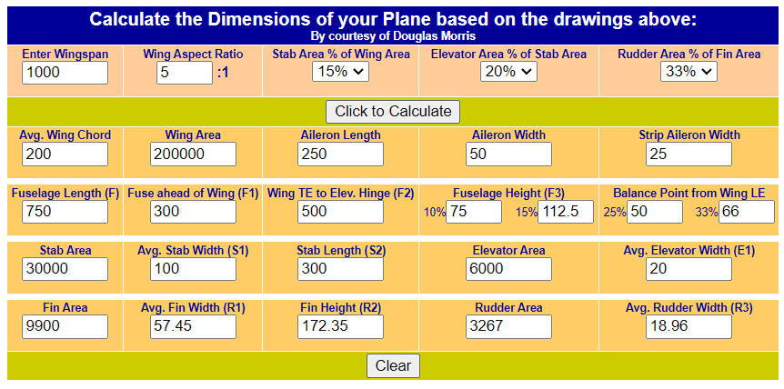

## Wing Loading

Based on an average chord of 200mm and 1000mm wingspan with the maximum weight of 1300 grams, our wing loading is roughly 65 g/sq.dm. This is in a good range for our aircraft and means that any weight we save will make this value decrease, marking this as our max wing load value.

# Systems Engineering Functions

Here I will attempt to go through each function and attempt to perform them at this stage.

## SE Function 1: Mission Objectives and Constraints

The goal of this project is to develop, design, and test a 3D printed remote-controlled aircraft capable of decent flight time and potential for payload. Due to the nature of the project, goals and requirements at this stage are ambiguous and lack many hard-set constraints. I will go through and list the current objectives and constraints and attempt to provide a range of required performance to then use moving forward in Phase A – Concept and Technology Development

## SE Function 2: Derived Requirements Development

### Project Objectives and Constraints List

* The aircraft frame should be made from a 3D printable material. Using personal printers, individual part sizes should not exceed 200mm x 200mm x 200mm. This is to limit the potential for print failure as the larger pieces result in more time to print. Also, as prints move from the center of the build plate, issues arising from leveling and bed adhesion become more common.
* The aircraft wingspan should be less than 1500mm. This is a personal decision, but I believe that increasing the aircraft leads to higher costs in terms of material and electronics and will become more costly to continue the project should multiple failures occur during testing phases. The minimum wingspan size will likely be dictated by the desired performance of the aircraft in terms of payload size and aircraft weight.
* The vehicle must function on either 2S or 3S lipo batteries. I would prefer to be able to utilize a 2S due to the lighter weight. I, however, understand that given the weight of the aircraft I may need a higher voltage.
* Looking at some forums of RC Plane flyers, for a beginner flyer I am looking at a cruising speed of roughly 20-30 mph or 9 – 13.5 m/s. This should provide a low minimum runway distance. The slow speed should also ensure that I am able to watch and critique the performance of the aircraft during passes.
* So, I do not have any desired weight limits, however I believe something less than 1,000 grams would be good in terms of manufacturing time. It will give me a targeted motor thrust output. I will look for a Thrust to weight ratio of between 0.2 and 0.5. At my limit, that would require a motor thrust between 200 and 500 grams.
* I am looking for a flight time of at least 10 minutes, this is a minimum, but my preferred range would be around 20 minutes.
* The aircraft should be operable with a payload that will include a more advanced flight controller such as a Navio2. While I do not have the exact weight of the flight controller currently, I would estimate it will be no more than 300 grams.

### Identified Objectives and Constraints

* Made from 3D Printed Material.
* Individually printed pieces should not exceed 200mm x 200mm x 200mm.
* Aircraft wingspan to not exceed 1500mm.
* Electrical voltage will be either 2S or 3S Li-Po
* Aircraft Cruising speed: 9 – 13.5 m/s
* Vehicle weight less than 1,000 grams
* Thrust to weight ratio: 0.2 – 0.5.
* Motor Thrust: 200 – 500 grams
* Capable of flying for at least 10 minutes, 20 is preferred.
* Capable of carrying an extra 300-gram payload.

## SE Function 3: Architectural Design Development

## Power Subsystem

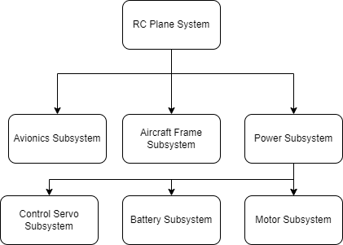

## Avionics Subsystem

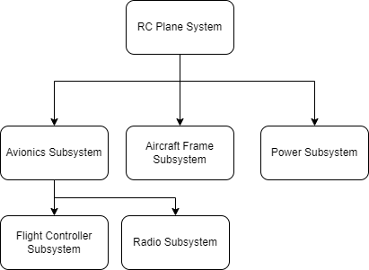

## Aircraft Frame Subsystem

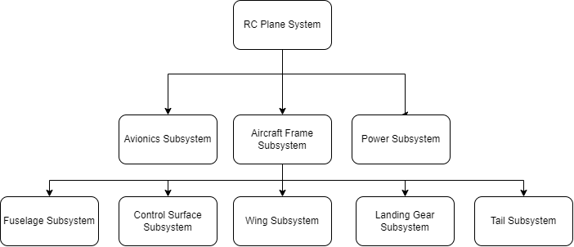

## SE Function 4: Concept of Operation

## SE Function 8: Technical Resource Budget Tracking

Expected Budgets we plan to track during the project:

### Mass Budget

So, I will want to keep an eye on at least the components I can get the exact weight of for now. I will do this in an excel document then transfer the finished over here.

### Cost Budget

Keeping an eye on just what I know of so far, obviously the motor and propellor will depend on further development as well as aircraft from cost in terms of printed material, rods, etc.



## SE Function 9: Risk Management

### Avionics Sys. Failure Modes



### Power Sys. Failure Modes



### Aircraft Sys. Failure Modes



## SE Function 10: Configuration Management and Documentation

All content except Fusion360 files will be stored in GitHub. Project management will also be done through GitHub to maintain traceability. If Fusion360 files are added, they can be uploaded daily with provided changes.

## SE Function 11: System Milestone Reviews and Reports

As I am the stakeholder, my reviews are kind of to myself? I can mark milestones using GitHub to identify major areas of the project such as finishing phases and scheduled testing dates.